WHAT IS THIS?
STRAIGHTFORWARD ROLEPLAYING 1.02
This is a toolbox rule-system. Just bare bone mechanics without any flavor. The rules are, as the name suggest, straightforward and should be easy to ‘hack’ into any kind of game you like by changing the list of skills or adding a few custom rules.
It’s a skill based system with no experience point or classes. The main inspiration is Basic Roleplaying by Chaosium. Other noteworthy mentions are D20, Kutulu and Hjältarnas Tid.

This document is licensed under Creative Commons 4.0 Attribution. That means you may use it any way you like as long as you mention Straightforward Roleplaying.

If you’re reading this and feel that it’s not very original – well, that’s the point. It’s not trying to be clever, it’s trying to be Straightforward.

CORE MECHANIC
All skills have a value ranging from 1-20. To test a skill roll under or equal the skills value with a twenty sided dice.

CREATE A CHARACTER
Characters have Common Skills and Specializations. Common Skills is the type of skills that anyone can attempt and Specializations represent areas of knowledge that a character get from her profession or interests.
- Choose a name and make up what kind of character you want to create.
- Assign this array of numbers any way you want between the Common Skills: 13, 11, 10, 9, 8. Remaining Common Skills receive the value 5.
- Assign this array of numbers to the Specialization Skills: 13, 8. Remaining receive the value 2.
- You have a chance to raise any four skills, roll 1D20 for each. If the result is higher than the current value it is raised by 1D4. You may try several times on the same skill but beware not to waste a roll, you can’t raise a skill higher than 16 at character creation.
- Health points is equal to 1D10+15.
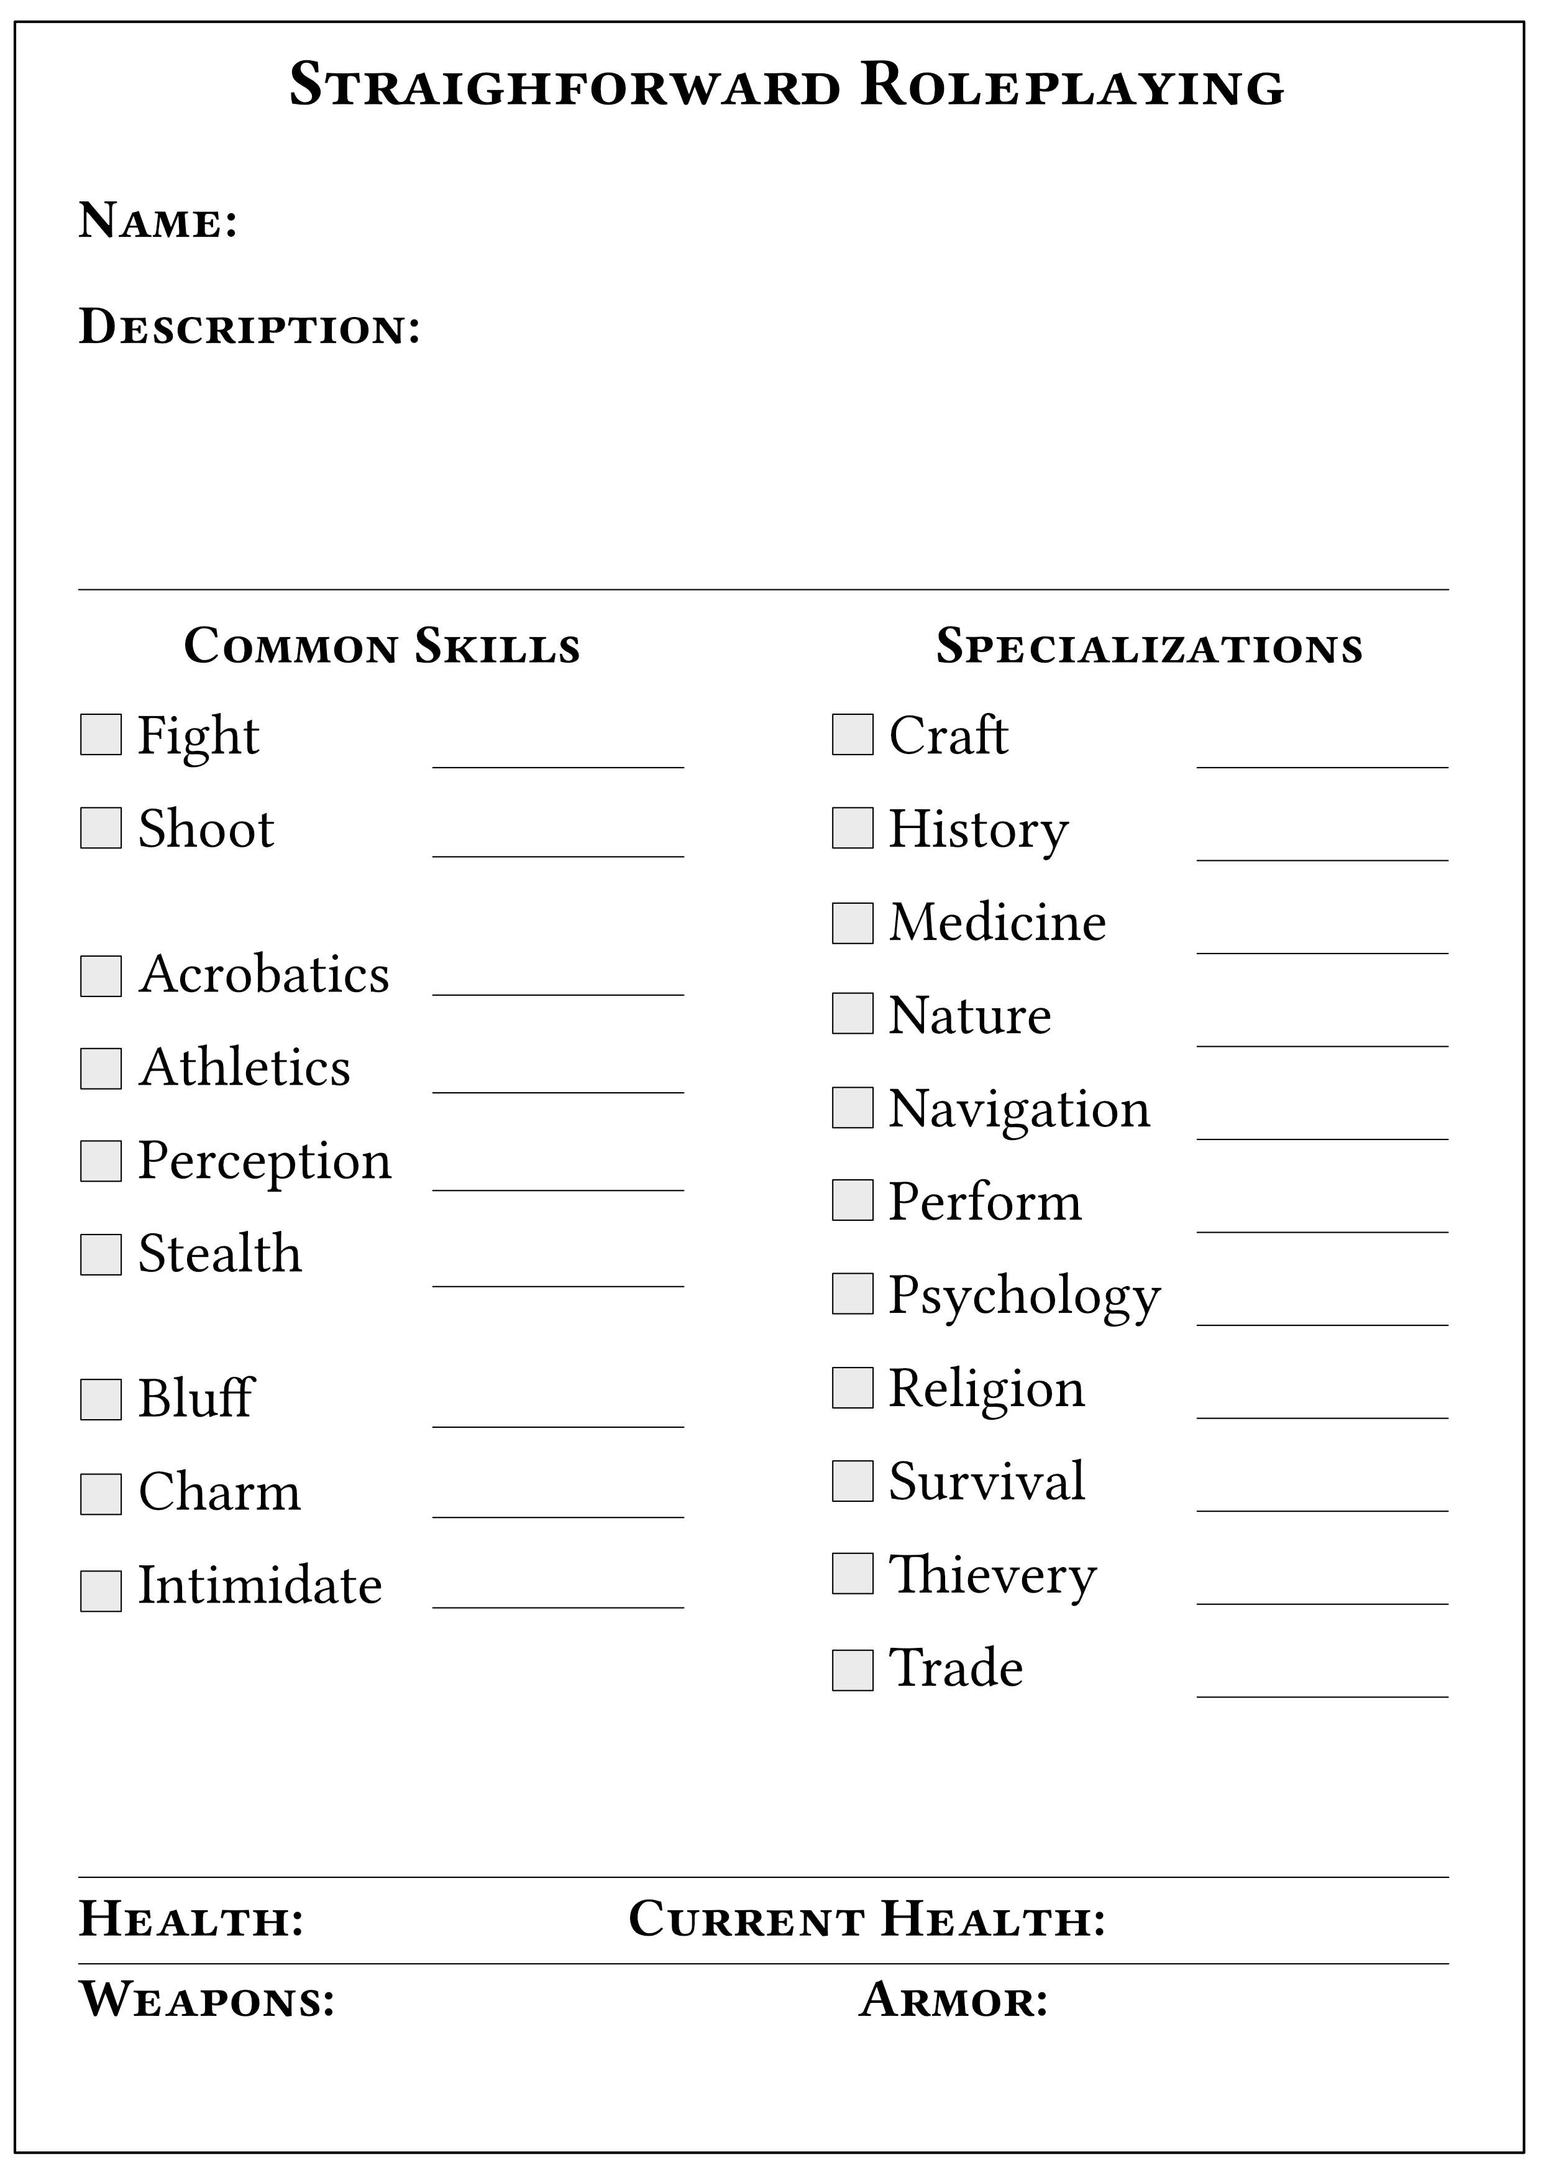
- Get equipment. The character starts with what makes sense for the character, her social standing and the setting.

RULES

Skill Tests
Sometimes a Skill Test is required to determine if a character is successful. To do this roll 1D20, if the result is lower than the skill the test is successful, else it has failed. The GM may temporarily adjust the skill with +5 for an easy test and -5 for a hard.
Example
Camilla is picking a lock. Her skill in Thievery is 12. She rolls 1D20 and gets 15. The lock won’t open.

Trying Again
It’s OK to try again if the first try was unsuccessful but this should always be connected with a risk of some sort. It’s up to the GM to let the player know what bad thing might happen if the player fails again.
Example
Camilla decides to try one more time to pick the lock. She rolls 1D20 and gets 19, fail again! Her lock pick breaks and gets stuck in the lock.

Advantage/Disadvantage
Sometimes a character may have Advantage or Disadvantage. For Advantage the player rolls 2D20 and takes the lowest result, for Disadvantage she rolls 2D20 and takes the highest. Examples of Advantage is preparation or a tool. Examples of Disadvantage is injury or stress.
Example
Hugust have spent all night in the library studying the forbidden verses of Rathuul. He now feels well prepared to cast the spell of Many Arms. The player must roll under 10 to succeed with the task but due to his preparation he have Advantage. He rolls 2D20 and gets 15 and 4. He takes the lowest result, 4 which is a success.

Opposed Skill Tests
When two characters is trying to best each other they make an Opposed Skill Test. They both roll the appropriate Skill. The player that make her test win. If both make their tests the character with the highest dice result win. If both fail it’s makes for a status quo situation where nothing happens.
Example
Sofia is trying to sneak past a guard. The guard have 13 in perception, he rolls and get 6. Sofia have 11 in stealth, she rolls and get 9. Sofia’s result (9) is higher than the guards(6) so Sofia wins the Opposed Test and sneaks unnoticed past the guard.

Character Advancement
During a game session if a player is successful in a Skill Test she may put a mark in the checkbox by the skill on the character sheet. When the session is concluded, for each marked skill the player may roll 1D20. If the result is higher than the skills current value the skill is raised by 1.

COMBAT RULES

Rounds
When combat begins time is measured in rounds where one round equals 10-20 seconds. Every round all involved character makes their actions in order.

Initiative
Usually the character that strikes first have the initiative. The rest of the turn order should be set by the situation - what makes sense.
For some groups this is to vague and dice need to be rolled, then roll a Perception Test, the characters are ordered by success and highest rolls, like in an Opposed Test.

Actions
Every round a character can Move and make an Action. A normal person can move 10m(30f) in one round. An Action is normally an attack but could potentially be something else like opening a lock or change gear. Talking or shouting is normally free and characters may do that as they please.

Melee Attack
Melee attacks are resolved just like Opposed Tests, Fight vs. Fight where the winner inflicts damage on the looser.
A character with high Acrobatics may choose to Dodge the attack instead of fighting back. Then the test is settled Fight vs. Acrobatics and the dodging character do not inflict damage on the attacker if winning the test.

Ranged Attack
A ranged attack is an Opposed Test, Shoot vs. Acrobatics.
To make a ranged attack you should be more than 3m(10f) away from the target.

Damage
Weapons deal damage according to their description. All damage rolls are Exploding. What that means is that if the highest possible result is rolled on a die you get to re-roll that die and add the result to the total. This way any weapon can, by chance, be deadly.
Sample Weapon List:
Dagger 1D4
Sword 1D6
Bow 1D6
Two Handed Sword 2D6
Pistol 3D6
Shotgun 4D6

Armor
Armor blocks damage according to it’s description. Armor rolls are not, like damage rolls, Exploding.
It is likely that a person wearing heavy armor have Disadvantage on Acrobatics and Stealth Tests.
Sample Armor List:
Leather Armor 1D6
Metal Harness 1D8
Full Plate 2D6
Example
A guard shoots Camilla with his revolver. He rolls 3D6 for damage. One of the die ends up a 6 so he re-roll that die and adds the result. The total is 4+6+3+2=15. That is a lot of damage! Camilla wears light armor so she rolls 1D6 and gets 4. Camilla takes 15-4=11 damage.

Injury and Healing
There are four degrees of injury:
Bruised, HP higher than 15
Heals all damage from one good nights sleep.
Hurt, HP 15 or lower
Heals 1 HP per day of rest.
Wounded, HP 10 or lower
Heals 1 HP per week of rest. Needs medical attention. A wounded person have Disadvantage on Acrobatics, Athletics, Fight and Stealth Skill Tests.
Severely Wounded, HP 5 or lower
Heals 1 HP per month of rest. Needs surgery and medical attention. This kind of damage may mark a character for good. It could be a severed arm or some such severe damage. A Severely Damaged character have Disadvantage on all Skill Tests.

SKILL DESCRIPTIONS

Acrobatics
Dodging, climbing a wall or jumping between rooftops.

Athletics
Lifting heavy things. Breaking down doors.

Bluff
Pulling a fast one. Pretending to be someone that you’re not.

Charm
Talk your way past the receptionist. Convince someone to give you a ride.

Craft
It should be determined at character creation what kind of craft the character knows. This could be carpentry, masonry, car repairs - anything that makes sense.

Fight
All types of fighting in close combat.

History
Knowledge about what king killed who when or who originally built the lost temple. You might be able to read some dead language.

Intimidate
Make people see things your way.

Medicine
Identify cause of death. Give medical care. Know chemical substance.

Navigation
You know how to read a sea chart and may know direction from looking at the stars.

Perception
Notice something hidden. Sense that someone is spying on you from across the street. Gain initiative in combat.

Perform
It should be determined at character creation what kind of art the character knows. Singing, dancing, acting, painting – anything artistic.

Psychology
Determine motives or what seems to be troubling a person. Calm someone that’s having a nervous breakdown.
Religion
Knowledge about theology and religions. You may recognize the weird symbols painted on a murder victims walls or what ancient demon god was worshiped in the area a millennia ago.

Shoot
All kinds off attacks with ranged weapons.

Stealth
Sneaking and hiding.

Survival
You know how to find shelter in a storm, track animals and find eatable berries in the wild.

Thievery
Pick a lock, pick a pocket, hot-wire a car, know a shady person that sell illegal weapons.

Trade
Knowledge about economy and trading. Check a ledger for strange posts. Haggle at the market. Appraise a piece of jewelry.

